Exercise 1: For the following codes carry out the analytical analysis to evaluate time complexity and then express it in terms of Big O:

1.  int sum,i;  sum = 0;  for (i=0;i<n;++i)  sum++;  Time complexity= 3n + 3  Big O= n | 2.  int sum,i,j;  sum = 0;  for (i=1;i<n;i=i*2)  sum++;  Time complexity= 3log2n + 3  Big O= log2n
3.  int sum,i,j;  sum = 0;  for (i=0;i<n;++i)  {  for (j=0;j<n;++j)  { sum++;  }  }  Time complexity= 3n^2 + 4n + 3  Big O = n^2 | 4.  int sum,i,j;  sum = 0;  for (i=1;i<n;i=i*2)  {  for (j=0;j<n;++j)  { sum++;  }  }  Time complexity= 3nlog2n + 4log2n + 3  Big O= nlog2n

Exercise 2: Execute the codes given in the table below and note the time of execution of each by setting the value of n=1000 to 10000000. Compare your results with the analytical results for the same codes in Exercise1.
int sum,i;  sum = 0;  for (i=0;i<n;++i)  sum++;  Tn=0,0.002,0.02 | int sum,i,j;  sum = 0;  for (i=1;i<n;i=i*2)  sum++;  Tn=0,0,0
int sum,i,j;  sum = 0;  for (i=0;i<n;++i)  {  for (j=0;j<n;++j)  { sum++;  }  }  Tn =19.727, | int sum,i,j;  sum = 0;  for (i=1;i<n;i=i*2)  {  for (j=0;j<n;++j)  { sum++;  }  }  Tn=0.004,0.039,0.466

Exercise 3:
Input_Numbers [10]=[10000, 20000, 80000, 150000, 250000, 400000, 800000, 900000,1500000,200000]
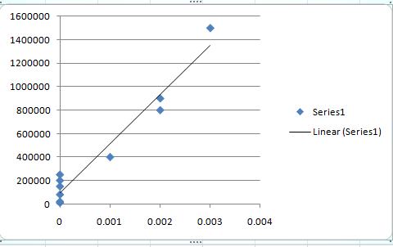

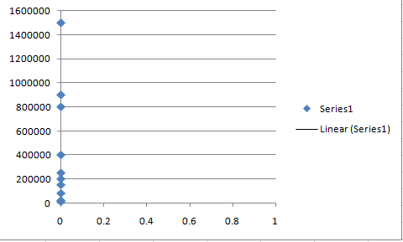

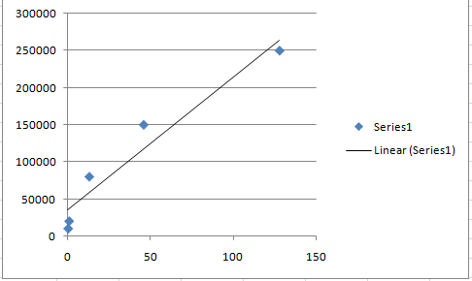
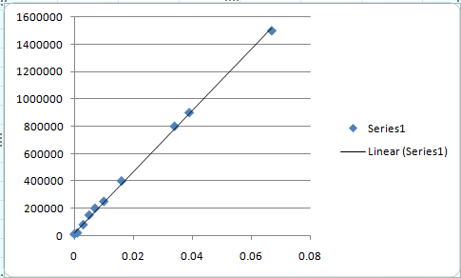

Exercise4:
Write a program to find the factorial of a given number
- iteratively

#include <iostream>
using namespace std;
void main()
{
int n,fact=1;
cout<<"ENTER THE NUMBER : "<<endl;
cin>>n;
for (int i=n;i>0;i--)
fact=i*fact;
cout<<"THE FACTORIAL OF THE NUMBER "<<n<<" IS "<<fact<<endl;
system("pause");
}

- recursively.

#include <iostream>
using namespace std;
int factorial(int n)
{
if(n<=1)
return 1;
else
return n*factorial(n-1);
}
void main()
{
int n,fact=1;
cout<<"ENTER THE NUMBER : "<<endl;
cin>>n;

cout<<"THE FACTORIAL OF THE NUMBER "<<n<<" IS "<<factorial(n)<<endl;
system("pause");
}

POSTLAB:

Execution time = 0.015
Big O =
Type of code =

